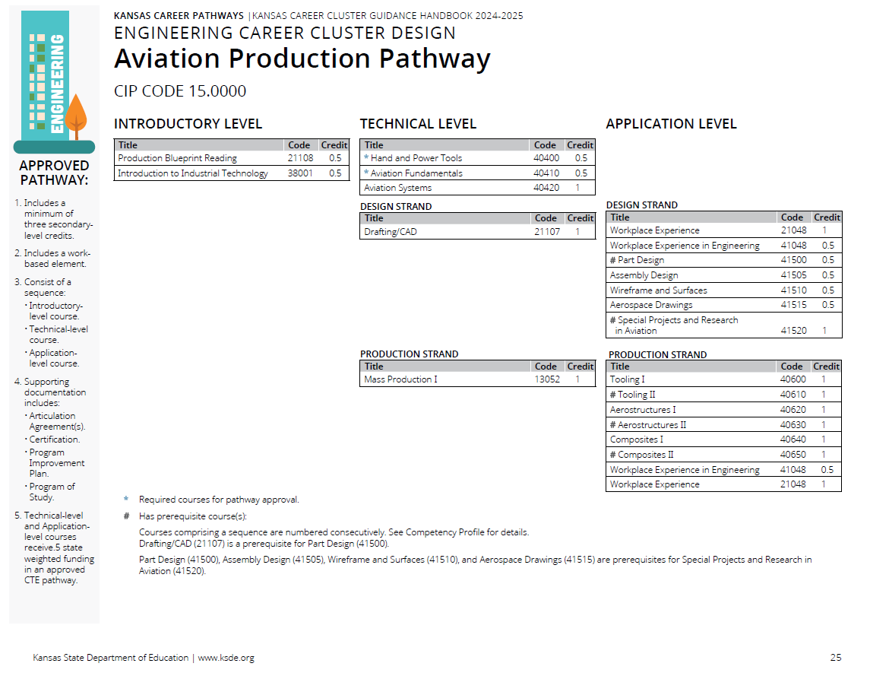

Prior to the Cluster Review

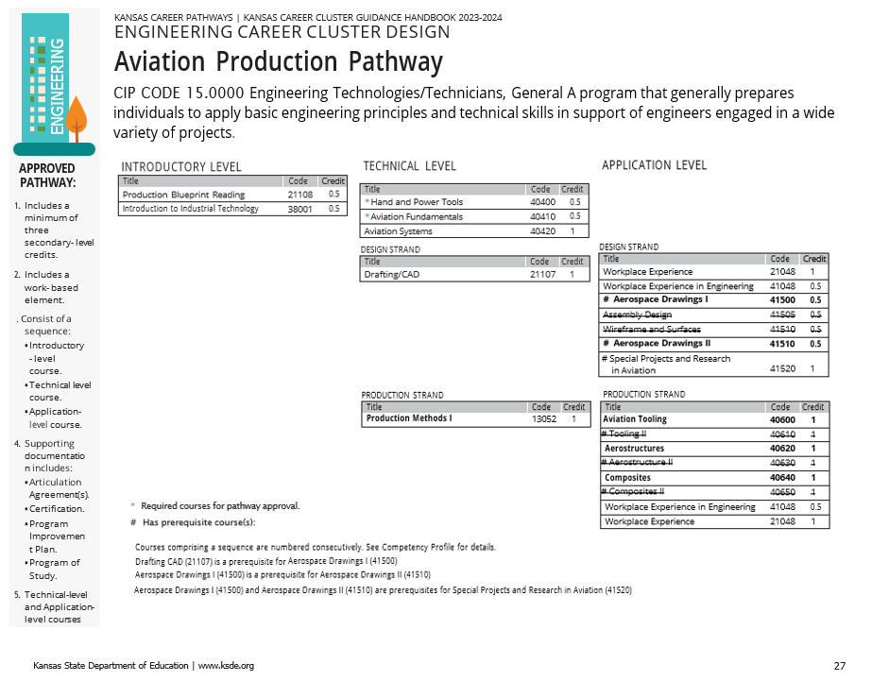
Recommendations Following Cluster Review

Pathway Recommendations Summary:

No Recommend Changes CTE Course Competencies and Indicators (ksde.org)
- Courses not reviewed by this committee.
  - 21108 Production Blueprint Reading
  - 38001 Introduction to Industrial Technology
  - 40400 Hand and Power Tools
  - 40410 Aviation Fundamentals
  - 40420 Aviation Systems
  - 21107 Drafting/CAD
  - 21048 Workplace Experience
  - 41048 Workplace Experience in Engineering
- Courses with No Changes
  - 41520 Special Projects and Research in Aviation

Courses Reviewed with Recommended Changes
- 13052 Mass Production I
  - Only changed Title to Production Methods I to match title in other pathways.
- Following Combined into 41500 Aerospace Drawings I
  - 41500 Part Design
  - 41505 Assembly Design
- Following Combined into 41510 Aerospace Drawings II
  - 41510 Wireframe and Surfaces
  - 41515 Aerospace Drawings
- Following Combined into 40600 Aviation Tooling
  - 40600 Tooling I
  - 40610 Tooling II
- Following Combined into 40620 Aerostructures
  - 40620 Aerostructures I
  - 40630 Aerostructures II
- Following Combined into 40640 Composites
  - 40640 Composites I
  - 40650 Composites II

